- Introduction
- Objectives
- Required Equipment and Components
- Bluetooth Low Energy Advertising
  - Advertising Packets
    - BLE Packet
    - Advertisement (or Advertising Channel) PDU
    - Advertisement Data Structure
- Task 1: BLE Firmware Development
  - Task 1.1: Prepare your Development Environment
  - Task 1.2: Configure Zephyr's BLE Functionality
    - Understand this output
  - Task 1.3: Start Sending BLE Advertisements
    - Configure the Advertising Payload
    - Start the Advertiser
    - Programme and Run the Advertiser
- Task 2: Find your Device in the BLE Scanner App
- Task 3: Add a Second Advertisement Element
- References

Introduction
In IoT systems, sensors are tools to convert real-world analogue values to digital values that can be understandable by digital devices. However, even with a rapid advancement in microcontrollers, it is still difficult to process large amounts of sensor data on the device locally due to the constraint processing power of the microcontrollers. Therefore, one of the solutions is to offload data from local devices to a more powerful machine, like a laptop. Although using a USB cable is always possible, modern IoT systems prefer wireless communication protocols for scalability. Bluetooth Low Energy (BLE) is one of those wireless communication protocols used by energy-constraint devices.

Objectives
At the end of this laboratory session, you will be able to:
- Develop firmware that allows you to send BLE advertisement packets from your nRF54L15DK device and perform basic manipulation of the content of those advertisements.
- Use a smartphone, tablet, or desktop app to view BLE advertisements and to identify the one coming from your device.

Required Equipment and Components
- Identical setup as for Lab Activity 1 (Your nRF54L15DK and the USB-C cable). You will not need the temperature sensor for this session.
- A mobile device (phone or tablet) or a laptop with Bluetooth support. Contact us if you are unable to bring your own device, or if you do not have access to a Bluetooth-enabled device.
- BLE Development and Testing Software (Desktop or Mobile app) on your device. Before you start working on the BLE advertisement firmware, it makes sense to first make sure you have a working BLE receiver / scanner. You have a few options:
- Mobile apps:
- nRF Connect for Mobile app on your smartphone, tablet. This is available for iOS / iPadOS and Android for free.
- LightBlue. This is also available for iOS / iPadOS for free.
- Desktop apps:
  - If you own a Windows laptop, we recommend using a BLE scanner app on a mobile device instead. We were unable to find any good, free BLE scanner desktop apps for Windows to recommend.
  - If you own a Mac, we recommend LightBlue.
  - Unfortunately you will be unable to use the Lab PCs as they do not have a Bluetooth interface
Make sure you have a working app on the device of your choice before you proceed.

Bluetooth Low Energy Advertising
The nRF54L15DK is a peripheral device that advertises its presence and configurable values to a central device. In this lab, the central device can be any device that has a scanning function, such as your phone, a laptop, or a tablet. We call this advertise-scan setup the Broadcast Topology as illustrated in Fig. 1.
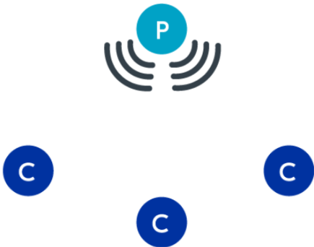
Figure 1 Broadcast topology with one peripheral and several central [1]
When a peripheral device is in an advertising state, it sends advertising packets periodically at advertising intervals on the advertisement channels.
Advertising intervals: The interval at which an advertising packet is sent. This is in the range of 20 ms to 10.24 s, with a step increase of 0.625 ms.
Advertising channels: The three primary frequency channels (Ch. 37, 38 and 39) on the 2.4 GHz band. See BLE Advertisment channels – SemFio Networks for more details.

Advertising Packets

BLE Packet
A standard BLE packet has the following format:
Preamble | Access Address | Protocol Data Unit | CRC
1 byte | 4 bytes | 2-39 bytes | 3 bytes
Table 1: BLE Packet Format

Advertisement (or Advertising Channel) PDU
The actual payload that will be used to save configurable values is the Protocol Data Unit (PDU) field. In the specific case of advertisements, the PDU part is also called "Advertising Channel PDU", which has the following format:
Header | AdvA | AdvData
2 bytes | 6 bytes | 0-31 bytes
Table 2: Advertisement PDU Format

Advertisement Data Structure
- AdvA is the Bluetooth address of the advertising device. In this case, it is our nRF54L15DK.
- AdvData is the actual advertisement data packet.
The BLE specification allows various types of Advertisement PDU types. In the type of advertisement that we will use, AdvData is effectively a sequence of 1 or more Length-Type-Value (LTV) advertisement (AD) tuples/elements named AD0, AD1 ... ADN:
 | AD Length | AD Type | AD Data
Advertising Element 0: AD0 | 1 byte | N bytes (usually 1) | (AD0 Length – N) bytes
Advertising Element 1: AD1 | 1 byte | N bytes (usually 1) | (AD0 Length – N) bytes
... | ... | ... | ...
Advertising Element N: ADN | 1 byte | N bytes (usually 1) | (AD0 Length – N) bytes
Table 3: Advertisement Data Structure
In this exercise, we will learn how to configure the AdvData field to follow a specific data format, including your sensor temperature value and a configurable device name. For detailed explanation on each field, check this website: Architecture of BLE.

Task 1: BLE Firmware Development

Task 1.1: Prepare your Development Environment
- Download a copy of the skeleton source code from GitHub https://github.com/g-oikonomou/advertiser/archive/refs/tags/lab-3/skeleton.zip
- Launch VS code → nRF Connect for VS Code → Click Open an existing application → Select the project folder that you downloaded in step 1.
- Click “Add Build Configuration”.
- Select the board target: nrf54l15dk/nrf54l15/cpuapp.
Choose the right core for your nrf54l15dk to be able to use BLE functions.
5. Set the base configuration file to prj.conf.

Task 1.2: Configure Zephyr's BLE Functionality
Open prj.conf to enable Bluetooth drivers by adding the following lines:
CONFIG_BT=y
CONFIG_BT_BROADCASTER=y
CONFIG_BT_OBSERVER=y
CONFIG_LOG=y
- You can now build your project now and then flash your board with the new firmware.
- Verify that the program runs and prints output. Open a nRF terminal (Not your windows terminal) with the correct COM port to connect to your device. This is what you should expect to see:
*** Booting nRF Connect SDK v3.1.1-e2a97fe2578a ***
*** Using Zephyr OS v4.1.99-ff8f0c579eeb ***
Starting BLE Advertiser Demo
[00:00:00.000,393] <inf> bt_sdc_hci_driver: SoftDevice Controller build revision:
fc de 41 eb a2 d1 42 24 00 b5 f8 57 9f ac 9d 9e |..A...B$ ...W....
aa c9 b4 34 |...4
[00:00:00.001,404] <inf> bt_hci_core: HW Platform: Nordic Semiconductor (0x0002)
[00:00:00.001,418] <inf> bt_hci_core: HW Variant: nRF54Lx (0x0005)
[00:00:00.001,430] <inf> bt_hci_core: Firmware: Standard Bluetooth controller (0x00) Version 252.16862 Build 1121034987
[00:00:00.001,827] <inf> bt_hci_core: HCI transport: SDC
[00:00:00.001,877] <inf> bt_hci_core: Identity: FF:55:F0:5A:21:DF (random)
[00:00:00.001,891] <inf> bt_hci_core: HCI: version 6.1 (0x0f) revision 0x3069, manufacturer 0x0059
[00:00:00.001,904] <inf> bt_hci_core: LMP: version 6.1 (0x0f) subver 0x3069
Bluetooth initialized

Understand this output
- Lines 1 and 2 are standard Zephyr OS boot messages
- Line 3 is in our own example code, near line 60 (L60): printk("Starting BLE Advertiser Demo\n");
- The function calls that follow in the lines below configure Zephyr's BLE functionality. The key function call in your code are:
bt_enable()
Because in prj.conf we have set CONFIG_LOG=y, Zephyr's BLE implementation prints out debugging messages for us. These are very helpful for development and debugging. In a production environment they would normally be disabled to save power. The output above was the result of the bt_enable() call. Notice that your device's identity will be different from the identity shown above.
- Line 14 also comes from our example code:
printk("Bluetooth initialized\n"); near Line 69.

Task 1.3: Start Sending BLE Advertisements
Our code is ready to send BLE advertisements, but it is not actually sending anything at all yet. We need to configure our advertisement payload and then start the advertiser.

Configure the Advertising Payload
Find the definition of the ad[] array near line 37 of our example code. It looks like this:
static const struct bt_data ad[] = {
};
This is the definition of the advertisement data structure in Table 3 above (AD0, AD1 etc). Currently, it is empty. Let's include the device name as the first element AD0 of our advertisement. Add
BT_DATA(BT_DATA_NAME_COMPLETE, DEVICE_NAME, DEVICE_NAME_LEN),
inside the definition of ad[]. It will now look like this:
static const struct bt_data ad[] = {
BT_DATA(BT_DATA_NAME_COMPLETE, DEVICE_NAME, DEVICE_NAME_LEN),
};
What we have done here is, we have used the BT_DATA Zephyr CPP macro to create an entry into our array, using:
- BT_DATA_NAME_COMPLETE as the type:
Control-click on BT_DATA_NAME_COMPLETE. VS Code should take you to the definition of that macro, in a file named gap.h. Here we see that this macro corresponds to a specific numeric value 0x09, which in the BLE specification corresponds to an advertisement element of type "Complete Local Name" or "Complete Name". This is among the most commonly-used element types.
- DEVICE_NAME as the value:
But we have not provided the actual name that we want to use anywhere. It comes from Line 18 in our example code:
#define DEVICE_NAME CONFIG_BT_DEVICE_NAME
Basically, what this does is, it sets DEVICE_NAME to be equal to the CONFIG_BT_DEVICE_NAME configuration parameter. This is a user-provided configuration, so it makes sense to do this in our configuration file. Openprj.confand add this at the bottom: CONFIG_BT_DEVICE_NAME="..."Replace ... with the name of your choice.
Anyone who scans for Bluetooth devices, including people outside this room, will see this name. Use appropriate language.
  - DEVICE_NAME_LEN sets the length of the value field. This is calculated using the CPP macro in line 19 of our example code:
#define DEVICE_NAME_LEN (sizeof(DEVICE_NAME) - 1)
This calculates the length of the DEVICE_NAME string. This is a pre-processor macro, which means the length is calculated at pre-process time (before we even compile). This is only possible because DEVICE_NAME is a constant and has a value that is known at compile time. Where the length changes at execution time, we need a different method to compute the length.
Why do we use minus one instead of just the size of DEVICE_NAME?
The table below shows the advertising element that you have just configured (assuming you used the word "George" as the name.
 | AD Length | AD Type | AD Data
Advertising Element 0  (AD0) | 0x07  (Includes the length of Type, but not the length itself) | 0x09  (Complete Name) | George  (That's 6 bytes)
Let's take a deeper look at the first element of the ad[] array. Looking at the definition of the array, it contains elements of type struct bt_data. If you control-click on bt_data VS Code should open the definition of this data type. It is in a Zephyr file called bluetooth.h, at line 531.
struct bt_data {
/** Type of scan response data or advertisement data. */
uint8_t type;
/** Length of scan response data or advertisement data. */
uint8_t data_len;
/** Pointer to Scan response or advertisement data. */
const uint8_t *data;
};
This is how the Bluetooth advertising structure is defined in C code. Looking at the definition of the structure is necessary to understand the types of each field, which in turn helps us write a debug statement and print their values.
printk("Element 0: T=0x%02x, L=0x%02x, V='%s'\n", ad[0].type, ad[0].data_len, ad[0].data);

This will print the content of the three respective fields in the nRF connect terminal window. Add this line in our example code file at line 72, after the printk("Bluetooth initialized\n");.
In the double quotation mark above, we used %02x, %s to specify the format of the variable. In C language, we call these format specifiers. For more information, you can refer to this page: Format Specifiers in C - GeeksforGeeks

Start the Advertiser
We now need to start the advertiser and point it to the location of the payload to use. Add the block of code below towards the end of our example file. Paste it starting at line 70, before the return statement of our main() function.
err = bt_le_adv_start(adv_param, ad, ARRAY_SIZE(ad), NULL, 0);
if (err)
{
printk("Advertising failed to start (err %d)\n", err);
return 0;
}

printk("BLE Advertiser Ready\n");
The main point of interest here is the bt_le_adv_start() function call. It configures and starts the Zephyr BLE advertiser:
- The first argument contains advertising parameters, including the min and max advertising intervals. The definition of this is provided for you already in our example code near line 49.
- The second argument points to the ad[] array that holds advertising elements.
- The third argument provides the length of the array, expressed as the number of elements.

Programme and Run the Advertiser
- Build the Firmware
- Flash your device
- Open the terminal to your device. You should see something like this:
*** Booting nRF Connect SDK v3.1.1-e2a97fe2578a ***
*** Using Zephyr OS v4.1.99-ff8f0c579eeb ***
Starting BLE Advertiser Demo
[00:00:00.000,393] <inf> bt_sdc_hci_driver: SoftDevice Controller build revision:
fc de 41 eb a2 d1 42 24 00 b5 f8 57 9f ac 9d 9e |..A...B$ ...W....
aa c9 b4 34 |...4
[00:00:00.001,412] <inf> bt_hci_core: HW Platform: Nordic Semiconductor (0x0002)
[00:00:00.001,426] <inf> bt_hci_core: HW Variant: nRF54Lx (0x0005)
[00:00:00.001,438] <inf> bt_hci_core: Firmware: Standard Bluetooth controller (0x00) Version 252.16862 Build 1121034987
[00:00:00.001,839] <inf> bt_hci_core: HCI transport: SDC
[00:00:00.001,889] <inf> bt_hci_core: Identity: FF:55:F0:5A:21:DF (random)
[00:00:00.001,903] <inf> bt_hci_core: HCI: version 6.1 (0x0f) revision 0x3069, manufacturer 0x0059
[00:00:00.001,917] <inf> bt_hci_core: LMP: version 6.1 (0x0f) subver 0x3069
Bluetooth initialized
Element 0: T=0x09, L=0x14, V='EEMEM0018 IoT SP Lab'
BLE Advertiser Ready
- Lines 1-14 inclusive are identical to the above
- The lines of interest here are 15 and 16. They show us the intended payload of the advertisement and that the BLE advertiser has started successfully. On line 15 you should see the name that you selected and the corresponding length, which will be different to what is shown here.

Task 2: Find your Device in the BLE Scanner App
- Open your scanner application and wait a moment
- You will see a very long list of devices. In these screenshots, the Device Name in Advertising Element 0 has been set to "EEMEM0018 IoT SP Lab". Try to find your device!
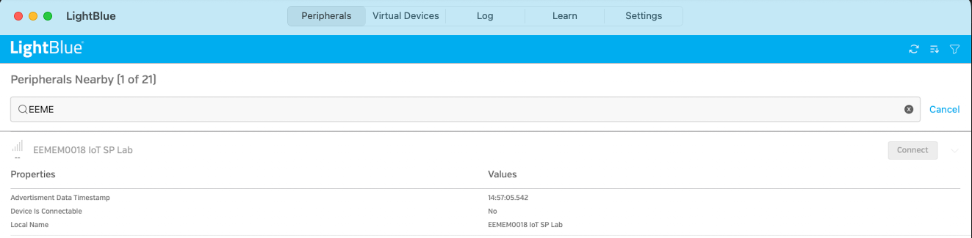
Figure 1: LightBlue on Desktop
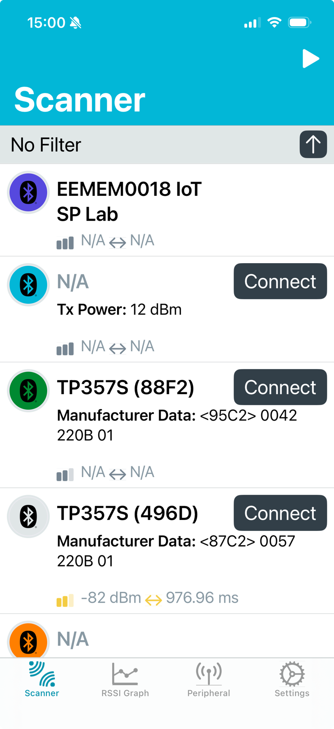
Figure 2: nRF Connect on Mobile

Task 3: Add a Second Advertisement Element
We are currently simply advertising the device's name. Time to add some sensor values in it. The way we do this will be through "Manufacturer Specific Data" element type. This allows us to insert pretty much anything we wish in an advertisement packet, subject of course to total packet length limitations. We will use this element type to insert a mock sensor reading.
- We need a data type to hold the information that will go inside the element. This is found in line 24 of our example file:
// Define Manufacturer Specific Data structure
struct adv_mfg_data {
uint16_t company_id;
int16_t temperature;
} __packed;
typedef struct adv_mfg_data adv_mfg_data_t;
- Manufacturer Specific Data must start with a 2-byte unsigned number identifying the manufacturer. In the data type definition above, this is captured in the company_id field. It corresponds to the identifier of the "Manufacturer" of this "Manufacturer-Specific Data". Each manufacturer of BLE hardware has a number assigned to them. As we don't have one we will use the value assigned to the Nordic Semiconductor. In a production environment we would need our own company's.
- temperature is a 2-byte, signed integer representing a temperature reading. We will add a mock number there for now.
- We subsequently need to define a variable of this type where we will store the actual data. Insert this block in line 24:
// Initialise data to be advertised
static adv_mfg_data_t adv_mfg_data = {
.company_id = COMPANY_ID,
.temperature = 0,
};
Note that adv_mfg_data_t is a new self-defined type. The actual variable name is called adv_mfg_data. To compare, if one defines a variable using uint16_t a, then uint16_t is the type of the variable, and a is the variable name.
This sets company_id to the value specified in the COMPANY_ID macro: 0x0059. This already happens at line 22, you don't need to add it:
#define COMPANY_ID 0x0059 // Nordic Semiconductor ASA
It also sets a mock, constant temperature value. Choose your own value here, it must be an integer! The above example code uses a value of 0.
- We actually need to put this inside the array of advertisement elements. That's the ad[] array and we need to extend it by including line 3 in the snippet below. The Manufacturer Specific Data in this case becomes element number 1.
static const struct bt_data ad[] = {
BT_DATA(BT_DATA_NAME_COMPLETE, DEVICE_NAME, DEVICE_NAME_LEN),
BT_DATA(BT_DATA_MANUFACTURER_DATA, (uint8_t *)&adv_mfg_data, sizeof(adv_mfg_data)),
};
- Lastly, let's add a debug statement to make sure we have done what we intended to do. Put this inside the main() function at line 79.
printk("Element 1: T=0x%02x, L=0x%02x, V='C=0x%04x, T=%d'\n", ad[1].type, ad[1].data_len,
((adv_mfg_data_t *)ad[1].data)->company_id, ((adv_mfg_data_t *)ad[1].data)->temperature);

- This is what our advertisement looks like now (T1 and T2 being the two temperature bytes)

 | AD Length | AD Type | AD Data
AD0 | 0x15 | 0x09 | EEMEM0018 IoT SP Lab
AD1 | 0x05 | 0xFF | 00 59 T1 T2
Build, programme your device and check the terminal. Expect this output:

Bluetooth initialized
Element 0: T=0x09, L=0x14, V='EEMEM0018 IoT SP Lab'
Element 0: T=0xff, L=0x04, V='C=0x0059, T=-4'
BLE Advertiser Ready
- Try to find this Manufacturer Specific Data in your BLE Scanner app!
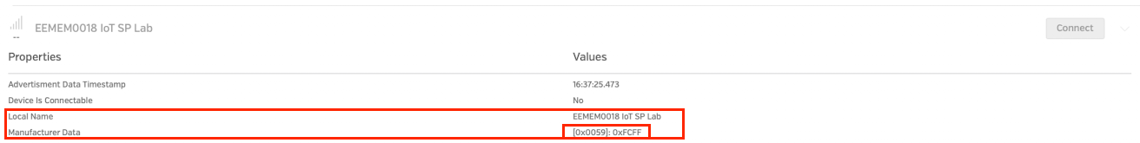

References
[1] GAP: Device roles and topologies - Nordic Developer Academy

